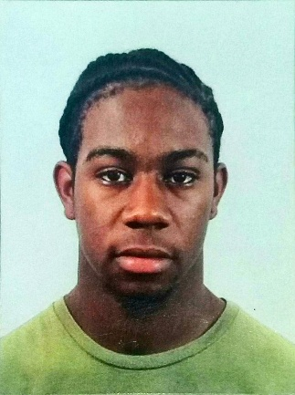Gabriel D. J. Baptiste

04/03/18.

18 years.

D.O.B. 10/02/2000,

Address: #7 Mount Olive Drive, Bagatelle Rd, D/M

Contact info: 752-1320.

Objective: To be a positive asset by achieving task assigned to me efficiently and accurate as possible while working with a more focused company.

Experience: Former warehouse attendant at Starlite Drugs El Socorro started April 2017 and Ended January 2018, This was a temporary job to help me out with schooling.

Education: English, Tec Drawing, Building Tec.

References: 1. Justin Bynoe

Student,

Contact info: 689-0866.

2. Lima Alexander

A Cook At TTFS,

Contact info: 361-8728.

Yours respectfully